NO.1 Which step must be taken in an application to use the IBM Single Sign On service for Bluemix PaaS?

- implement an authentication callback

- implement a login form requesting User ID and password

- configure the OAuth 2.0 client with the SSO service credentials

- securely store user credentials used for the external authentication

Ans - A

NO.2 A team of developers is working on a single repository in IBM Bluemix DevOps Services. Which DevOps feature should be used to confirm the integrity of their source code by running tests every time code is delivered to the shared repository?

- Source Control: Test code upon commit

- Web IDE: Enable Automatic Unit Testing

- Delivery Pipeline: Configure a build stage

- Track & Plan: Create a Work Item of type Test

Ans - A

NO.3
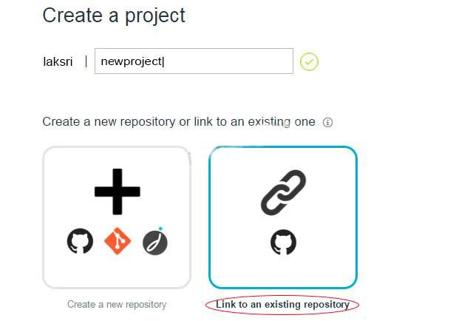

When creating a new project in IBM Bluemix DevOps Services, which action is performed when Link to an existing repository is selected?

A. An existing GitHub repository is linkedto the project by giving IBM DevOps Services access to a specified GitHub account.
- An existing Git project on the developer's local machine is linked to the project.

- An existing GitHub repository is linked to the project using anonymous access.

- An existing user's project in IBM DevOps Services is linked to the project.

Ans - A

NO.4 Based on the Twelve-Factor App methodology, where is the best place to store external configuration credentials in IBM Bluemix PaaS?

- in the source code

- in a user configuration file

- in an application database

- in the VCAP_SERVICESenvironment variable

Ans - D

NO.5
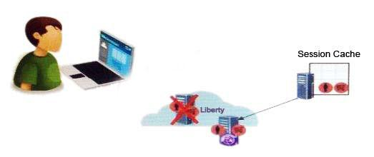

A developer has an application based on the Liberty profile running in IBM Bluemix PaaS. The developer wants to maintain high availability on HTTP sessions.

What is the benefit of using IBM Bluemix Session Cache service?

- Session data is shared across different browsers.

- Session data is automatically stored in remote file systems.

- Session data is encrypted and stored in a MySQL database.

- Session data is recovered after an application instance crashes.

Ans - D

NO.6 When a Node.js application is configured for IBM Bluemix Live Sync Debug mode, opening the url https://<app-host>.mybluemix.net/bluemix-debug/manage shows:
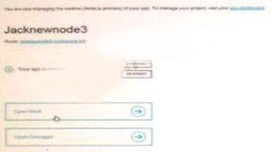

What will occur when the Restart button is selected?

- Redeploy and restart the application.

- Restart without redeploying application.

- Restart the managed services and not the application.

- Recycle the application memory and jump to the current breakpoint.

Ans - B

NO.7 In IBM Bluemix PaaS, what function is performed by the Router?

- controlling the number of application instances

- providing health status of running application instances

- routing log traffic to a third-party log management service

- provides request routing to access a running application instance

Ans - D

NO.8 Which component is responsible for managing the deployment of an application running in IBM Bluemix PaaS?

- Router

- Load Balancer

- Health Manager

- Cloud Controller

Ans - D

NO.9 Which statement is correct regarding the capabilities available on the Run Query tab shown in the image of the SQL Database Service web console to manage instances in IBM Bluemix PaaS?
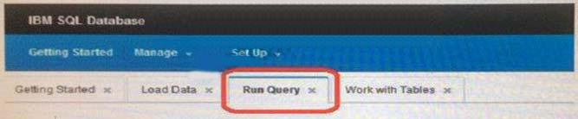

- OnlySQLSELECTstatements are allowed.

- The queries can only be generated through a wizard.

- Queries can use JSON documents as SQL command arguments.
D. A maximum of 500 rows of data can be returned from each query.

Ans - A

NO.10 Where are objects such as images, audio and video files stored in IBM Object Storage?

- Group

- Folder

- Bucket

- Container

Ans - D

NO.11 What are three types of work items available in the IBM Bluemix DevOps Services Track & Plan feature? (Select three.)

- PMR

- Task

- Story

- Sprint

- Defect

- Test Plan

Ans - B,C,E

NO.12 What are the two key elements defined in an Organization in IBM Bluemix PaaS? (Select two.)

- Cities

- Users

- Routers

- Spaces E Regions

Ans - B,D

NO.13 What are the two key benefits of Cloudant Sync? (Select two.)

- Sensitive data is encrypted by default before replication.

- Replication is extremely fast because it is limited to documents less than2KB in size.

- The distributed database architecture is more scalable than a single central database.

- It enables mobile device apps accessing the database to operate without a network connection.

- It significantly reduces the amount of storage needed once all participating databases are in sync.

Ans - C,D
NO.14 What is the output of the cf apps command?

- a list of all the applications and services for the developer's organization

- a list of services bound to each application for the developer's organization

- a list of all the running applications on IBM Bluemix PaaS with application owner ID

- a list of all the applications in the developer's space with the name and resource utilization

Ans - D

NO.15 Which statement characterizes the dashDB service?

- It is optimized for time series data.

- It is designed for analytic queries.

- It is optimized for normalized data.

- It is based upon the MySQL engine.

Ans - B
NO.16 What allows for the sharing of variables across any job in a stage in the Delivery Pipeline of IBM Bluemix DevOps Services?

- environment properties

- the Admin options in the Project settings

- a flag passed to the job when it is executed

- a setting in the project's properties called Shared Variables

Ans - A

NO.17 A developer wants to deploy and start a large application to IBM Bluemix PaaS. When they enter the command cf push appname, the following error is shown:

0 of 1 instances running, 1 starting 0 of 1 instances running, 1 down FAILED Start app timeout What option is available for the developer to resolve the issue?

- Increase the start timeout in manifest.yml of the application.

- Increase the deploy timeout in manifest.yml of the application.

- Increase the upload timeout in manifest.yml of the application.

- Increase the staging timeout in manifest.yml of the application.

Ans - A

NO.18 A developer's application is falling to work correctly in IBM Bluemix PaaS. The developer is unsure if the problem is caused by a bad environment value or a bug in the code. How should they
proceed?

- Rebind the service associated with VCAP_SERVICES.

- Usecfenv<app_name>to get all the environment variables forthe application.

- Delete the service associated with VCAP_SERVICES and recreate it without rebinding.

- Usecf set-env<app_name>to set all environment variables to null for the application.

Ans - A

NO.19 According to this application Overview panel image, how is the memory quota (measured in MB) applied to the two instances?
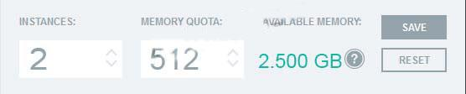

- each instance gets 512 MB of memory

- each instance shares the available memory

- the instance that receives the most traffic gets the most memory

- the instance will divide the memory quota evenly, each receiving 256 MB of memory

Ans - A

NO.20 The following document exists in a Cloudant database named invoices created by user candidate
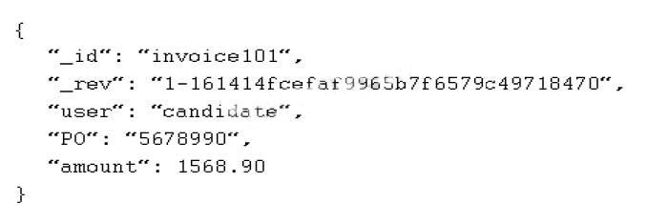

What information is required in order to delete it?

- the document's_idonly

- the document_idanduser

- the document's most recent_revvalue only

- the document's_idand most recent_revvalue

Ans -D

NO.21 A developer has an application and they wish to make it available as a service through IBM Cloud. Which two options are available for publishing the solution? (Select two.)

- IBM Cloud

- IBM SoftLayer

- IBM Cloud Marketplace

- IBM Connections Cloud

- IBM Bluemix PaaS as a third-party service

Ans - C,E

NO.22 How are managed services from the IBM Bluemix PaaS catalog used in an application?

- Services can only be used by an IBMBluemix PaaS application with a signed one year agreement.

- Services can be found through the IBM Cloud Marketplace and must be purchased before using them.

- Services are ready for immediate use and can be used by any IBM Bluemix PaaS application after binding.

- Services must be downloaded from IBM, third-party, or community locations and installed on a virtual machine before using them.

Ans - C

NO.23 Which statement is true for binding services to IBM Bluemix PaaS applications?

- All service instances must be bound to an application.

- An application can bind to only one service instance of a given type.

- More than one application can bind to the same service instance of a given type.

- Two or more applications can not bind to the same service instance of a given type.

Ans - C

NO.24 Why would the Load Impact service in IBM Bluemix PaaS be used?

- For its ability to manage a sudden load increase in an application.

- For its ability to replicate instances across IBM Bluemix PaaS regions.

- For its ability to simulate user loads on IBM Bluemix PaaS applications.

- For its ability to increase application availability by increasing application instances.

Ans - C

NO.25 Applications A and B are configured to use IBM MQ Light for Bluemix messaging capabilities. Application A publishes messages to a topic. Application B subscribes to the same topic in order to receive the messages published by Application A.

What occurs when Application A publishes the message after Application B goes down?

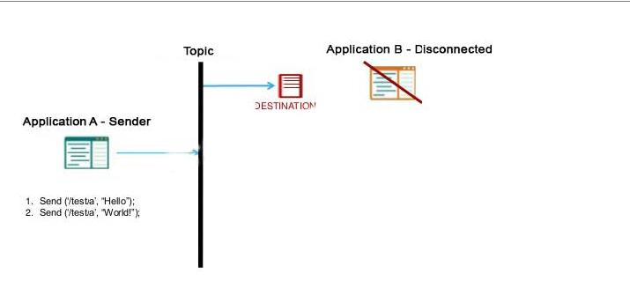

- Destination stores the message and it will be received if Application B comes back up before the destination time-to-live expires.

- Application A receives a notification from the destination that Application B is down.

- Topic stores the message forever, and the message will be received by Application B after it comes back up.

- Destination stores the copy of the message for one hour. If Application B does not come back up within one hour the message will be lost.

Ans - A

NO.26 In a hierarchical organization of related work items in the Track and Plan feature of IBM Bluemix DevOps Services, which type of work item would be at the top?

- Epic

- Task

- Story

- Detect

Ans - A

NO.27 A developer is going into production with a consumer web application in IBM Bluemix PaaS. The developer is keen to understand how the application is performing to maximize customer retention.

Where can the developer look to obtain a current display of CPU, disk and memory usage?

- Track and Plan

- Workload Scheduler

- Instance Details panel

- AppScan Dynamic Analyzer

Ans - C

NO.28 What is a Stage Trigger in Delivery Pipeline?

- an action that adds a new stage

- an action that tells a job when to execute

- an action that pushes code changes to git

- an action that updates a work item in Track & Plan

Ans - B

NO.29 Which three features are provided by IBM Bluemix DevOps Services? (Select three.)

- web code editor

- Delivery Pipeline

- database management

- application usage statistics

- source control management

- automatic unit test generation

Ans - A,B,E

NO.30 Which two statements are correct regarding SQL scripts in the dashDB Service Web Console to manage instances in the IBM Bluemix PaaS? (Select two.)

- The script can be validated prior to running it.

- A script can be named and saved for later use.

- Syntax errors in the script can only be detected when the script is run.

- Unless specified otherwise via the dashDB configuration, Informix SQL syntax is used.

- Scripts can only containSQL INSERT, SQL UPDATE, and DDLcommands to create tables and views.

Ans - A,B

NO.31 A developer is going into production with a consumer web application in IBM Bluemix PaaS. The developer is keen to understand how the application is performing to maximize customerretention.

The scaling history for the application shows repetitive scale out and scale in actions. To reduce resources used by each instance startup, the developer wants the scaling service to wait longer before taking action. What parameter should be changed and how?

- increase the cooldown period for scaling in

- decrease the cooldown period for scaling in

- increase the cooldown period for scaling out

- decrease the cooldown period for scaling out

Ans - C

NO.32 A team is using IBM Bluemix DevOps Services to collaboratively develop their application. They are all members of the same project in IBM Bluemix DevOps Services.

The team lead has made some changes that need to be shared with the team. How can this be accomplished?

- Create a commit and push it to the repository.

- Edit the ACL for each changed file and give the team read access.

- Team members should log into IBM DevOps services with the User ID anonymous.

- Click the Share button in the IBM Bluemix DevOps web IDE after saving the changes.

Ans - A

NO.33 Based on the Twelve-Factor App methodology, how should developers share common code between two Node.js applications in IBM Bluemix PaaS?

- duplicate the common code in each application repository

- use only one repository for both applications and the common code

- use one repository for both applications and another repository for the common code

- create a npm package for the common code and add the dependency to it for both applications

Ans - B

NO.34 A developer is creating an application to search social media for pictures with specific content, What IBM Bluemix PaaS service should they use?

- DreamFace

- AlchemyAPI

- Personality Insights

- Monitoring and Analytics

Ans - B
NO.35 Applications A, B and C are configured to use IBM MQ Light for Bluemix messaging capabilities. Application A publishes messages as shown in the diagram. What messages are received by Applications B and C? (Select two.)
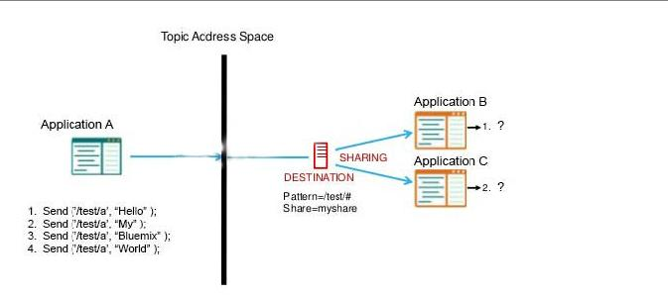

- Application C receives "My" "World"

- Application B receives "Hello" "World"

- Application B receives "Hello" "Bluemix"

- Application B receives "Hello" "My" "Bluemix" "World"

- Application C receives "Hello" "My" "Bluemix" "World"

Ans - A,C

NO.36 When defining a Cloudant view, what must be defined?

- a map function

- a sort function

- a reduce function

- a rereduce function

Ans - A

NO.37 Which two capabilities are available in the dashDB Service Web Console to manage instances in IBM Bluemix PAAS? (Select two.)

- sync data from an instance of Cloudant

- load Comma Separated Values (CSV) from an external file

- load relational data directly from another instance of dashDB

- load relational data directly from an instance of SQL Database

- load time series data directly from an instance of the Time Series database

Ans -A,B

NO.38 While using the Web IDE in IBM Bluemix DevOps Services, there is a need to change the Bluemix deployment region from US South to the United Kingdom. What must be edited?

- Launch Configuration

- IBM Bluemix DevOps Services User Profile

- IBM Bluemix PaaS manifest file (manifest.yml)

- application configuration file (package.json or server.xml)

Ans - A

NO.39 Which operation is supported by the development mode in Eclipse Tools for Bluemix in IBM Bluemix PaaS?

- initiate remote debug sessions with that application instance

- scale the application while load testing for development purposes

- send emails to developer when bug is hit or crash occurs on the application instance

- help develop the application by lockingthe access to the application and allowing a fix while nobody else can use it

Ans - A

NO.40 Which statement is true of the Cloudant NoSQL service?

- It prioritizes space savings over availability.

- It prioritizes immediate consistency over availability.

- It prioritizes availability over immediate consistency.

- It prioritizes immediate consistency over performance.

Reference:http://www.redbooks.ibm.com/redpapers/pdfs/redp5126.pdf(p.17)

Ans - C

NO.41 How are views created in Cloudant?

- by creating a PrimaryIndexwithdoc id's

- by creating a Secondary Index with doc id's

- by creating a Primary Index using the Map function

- by creating a Secondary Index using the Map function

Ans - D

NO.42 What is a boilerplate in IBM Bluemix PaaS?

- a script to build applications from scratch

- a service that can be bound to application

- a combination of a runtime and predefined services

- an external service that can be consumed by application

Ans - C

NO.43 Which two actions can be performed using IBM DataWorks Forge? (Select two.)

- create a new SQL database

- join data from multiple tables

- assess quality of sample data
- generate large sample datasets

- perform bulk updates to tables using natural language

Ans - B,C

NO.44 If you have an instance of myApp with 1GB of memory and 1GB of disk running on Bluemix PaaS, what is the result of the command cf scale myApp -k 2G?

- scalingthemyApp vertically by increasing the memory to 2GB

- scalingthemyApp vertically by increasing the memory to 3 GB

- scalingthemyApp vertically by increasing the size of the disk to 2GB

- scalingthemyApp vertically by increasing the size of the disk to 3 GB

Ans - C

NO.45 What is an example of an Auto-Scaling Service Policy Rule in IBM Bluemix PaaS?

- If the application is not accessed for 600 seconds, remove one instance.

- If the average disk space utilization exceeds 99%, add dynamic disk storage.

- If the average memory utilization exceeds 80% for 600 seconds, add one instance.

- If the average memory usage exceeds 80% for 300 seconds, add 64 MB of memory.

Ans -C

NO.46 After selecting All Documents in a Cloudant database using the Cloudant Dashboard, what is the result of selecting Include Docs in the Query Options and clicking Query as shown in the image?
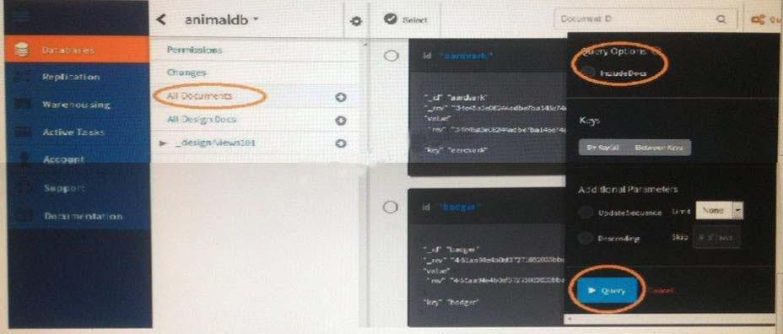

- A search index would be created for all the documents to make the query run faster.

- All fields from each document will be shown in the display.

- An error indicating an illegal operation is displayed because this option cannot be used unless a key range is specified.

- The summary is replaced with a link to download the entire contents of all documents.

Ans - B

NO.47 Which IBM Cloud offering model provides an IBM solution ready for use by customers?
A. Platform as a Service
- Software as a Service

- Application as a Service

- Infrastructure as a Service

Ans - B

NO.48 The docker search command $ sudodocker search centos produced the following output: NAMEDESCRIPTIONSTARS

OFFICIALTRUSTED

centosOfficial CentOS 6 Image as of 12 April 201488

Which command should be issued to download the centos image?

- cpdocker/centos

- sudodocker push centos

- sudodocker pull centos

- sudodocker download centos

Ans - C

Reference:http://www.ibm.com/developerworks/cloud/library/cl-docker-environment-bluemixtrs/index.html

15

